**Chapter 4 - THANK YOU MA’AM**

**All Lectures Uploaded on YouTube:** [**https://tinyurl.com/fkm10-english**](https://tinyurl.com/fkm9-english)

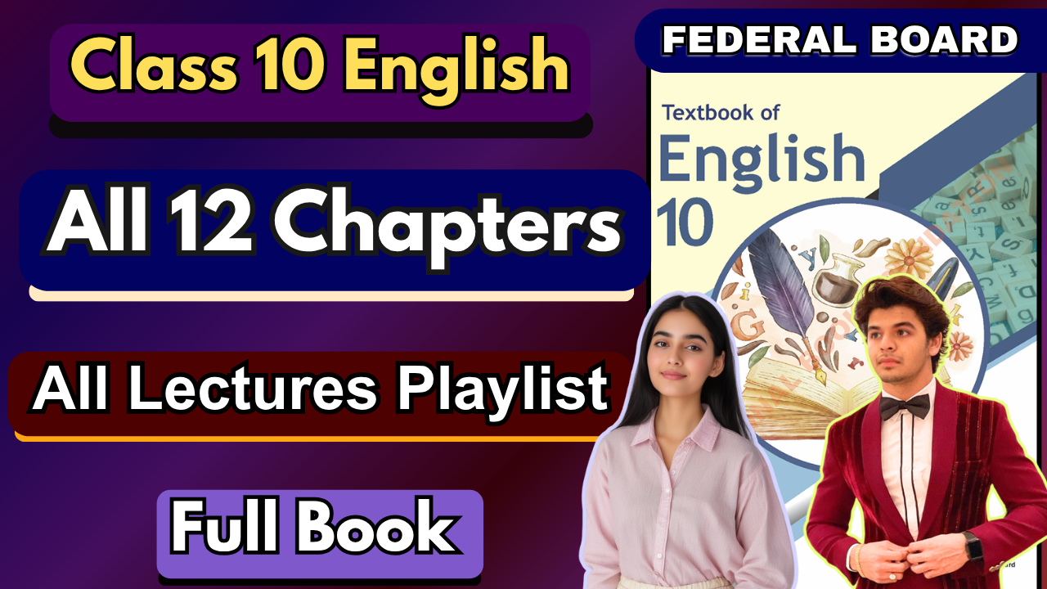

**Glossary:**

**Given below are the difficult words from the unit. Look at their meanings and use these words in your own sentences.**

| **Words** | **Meaning** |
| --- | --- |
| sling | to throw or fling something forcefully. |
| tug | to pull or drag with force. |
| sitter | a person or thing that is sitting. |
| frowned | to contract the brow, indicating displeasure or deep thought. |
| presentable | fit to be seen by others; looking neat and tidy. |
| mistrusted | to regard with suspicion or lack of confidence. |
| embarrass | to cause someone to feel awkward, self-conscious, or ashamed. |
| barren | unproductive; not producing results or fruit. |
| anticipate | to expect or foresee something happening. |
| consequences | the results or effects of an action or situation. |

The following are the sentences for the above mentioned words:

1. **Sling** – The soldier carried his injured arm in a **sling**.
2. **Tug** – The child gave a strong **tug** on his mother’s hand.
3. **Sitter** – The parents hired a babysitter to watch their children while they went out.
4. **Frowned** – The teacher **frowned** when the students arrived late to class.
5. **Presentable** – He wore a clean and **presentable** suit for the job interview.
6. **Mistrusted** – She **mistrusted** the stranger because he seemed suspicious.
7. **Embarrass** – His clumsy mistake did not **embarrass** him at all.
8. **Barren** – Nothing grew in the **barren** desert land.
9. **Anticipate** – The players eagerly **anticipate** the start of the final match.
10. **Consequences** – He realized his careless actions would bring serious **consequences**.

**Reading and Critical Thinking Skills**

**A. Choose the correct answer:**

**i. What did the large woman carry in her purse?**

a) Hammer and nails 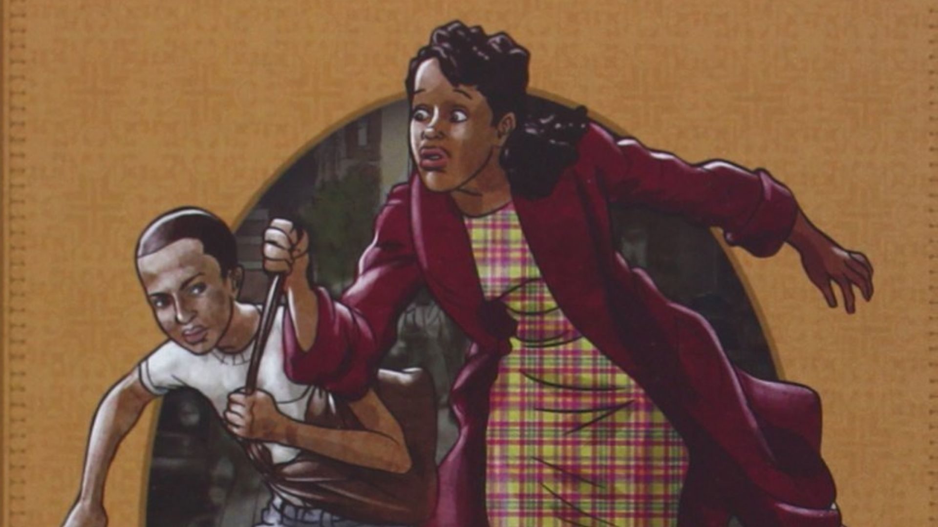

*b) Everything but hammer and nails*

c) Only money

**ii. How did the boy try to snatch the woman's purse?**

a) He pushed her

b) He pulled it from the front

*c) He ran up behind her and tugged*

**iii. Why did the strap of the purse break?**

a) The woman pulled it too hard

b) The boy tugged it from behind

*c) It was old and worn out*

**iv. How did the woman react when the boy fell after the purse-snatching attempt?**

a) She laughed

b) She ignored him

*c) She kicked him and picked him up*

**v. What reason did the boy give for trying to snatch the purse?**

a) He was hungry

*b) He wanted blue suede shoes*

c) He was dared by his friends

**vi. What did the woman offer the boy after the incident?**

a) A job

*b) Money for blue suede shoes* 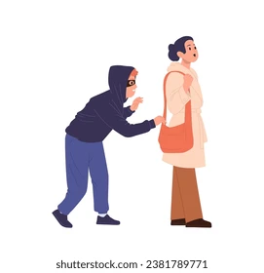

c) A lecture on good behavior

**vii. How did the woman teach the boy a lesson?**

a) She called the police

b) She shook him and scolded him

*c) she gave him a stern warning*

**B. Read the unit carefully and answer the following questions.**

**i. What did the large woman have in her purse, and what was missing from it?  
Ans.** She carried everything in her purse **except hammer and nails**, but it had **no money** inside at the time.

**ii. How did the boy try to snatch the woman's purse, and what happened as a result?  
Ans.** The boy **ran up from behind and tugged at the purse**, but the strap broke because it was old. He lost his balance, fell on the sidewalk, and got caught by the woman.

**iii. Describe the woman's reaction when the boy tried to snatch her purse.  
Ans.** Instead of letting him run, she **kicked him, picked him up by his shirt**, and scolded him strongly. She did not show fear but firmness.

**iv. Why did the boy want the woman to turn him loose?  
Ans.** He was frightened and wanted to escape because he feared she would hand him over to the police.

**v. What reason did the boy give for trying to snatch the woman's purse, and how did the woman respond?  
Ans.** The boy admitted he wanted money to buy **blue suede shoes**. The woman understood his desire but told him that snatching was not the right way, and she chose to guide him instead of punishing him.

**vi. What did the woman offer the boy after bringing him into her home?  
Ans.** She gave him food to eat and finally offered him **money to buy the blue suede shoes** he wanted.

**vii. How did the woman's attitude change towards the boy by the end of the story?  
Ans.** By the end, the woman’s harshness softened into **kindness and trust**. Instead of punishing him, she treated him with care, gave him advice, and offered money, teaching him a lesson in honesty and compassion.

**Elements of a Story**

Every story is made up of certain important elements that give it structure, meaning, and impact. These elements help readers understand the events, emotions, and messages conveyed by the writer.

### **1. Setting**

The **setting** tells where and when the story takes place. It includes location, time period, weather, and environment.

* *Example:* A haunted mansion at midnight, or a busy city street in modern times.
* **Use:** It creates mood, builds atmosphere, and gives context to the story.

### **2. Plot**

The **plot** is the sequence of events that make up the story. It usually follows this structure:

* **Exposition** (introduction)
* **Rising action** (conflicts and complications)
* **Climax** (turning point)
* **Falling action** (events after climax)
* **Resolution** (conclusion)
* *Example:* In “Cinderella,” the plot follows her hardships, the ball, the lost shoe, and finally her happy ending.

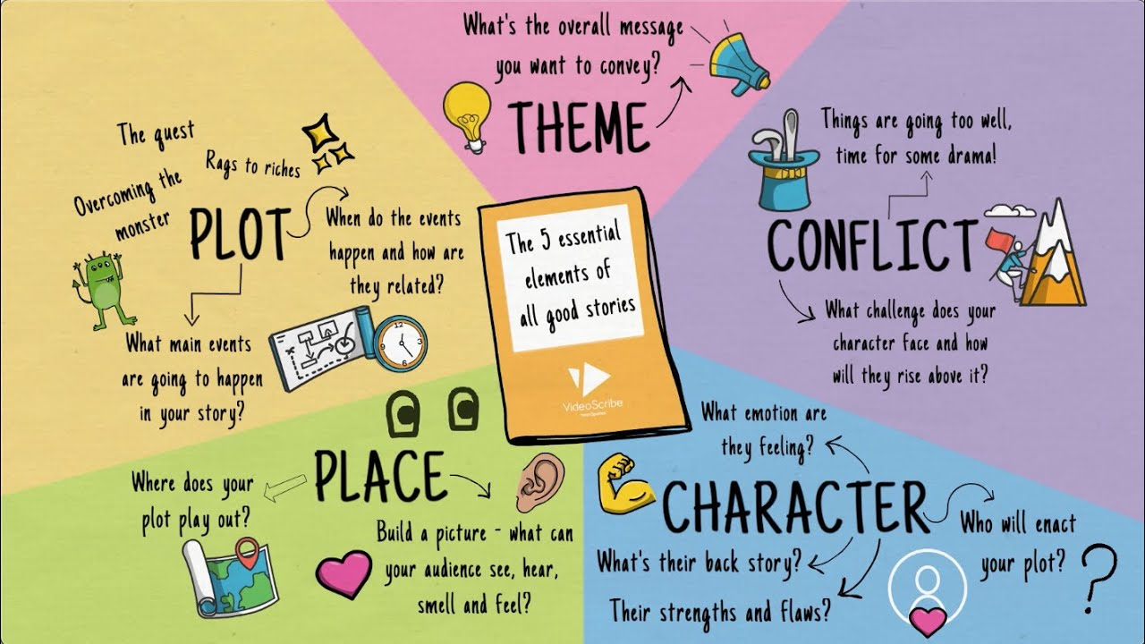

### **3. Characters**

**Characters** are the people, animals, or beings who take part in the story.

* **Protagonist** – main character (hero/heroine).
* **Antagonist** – character or force opposing the protagonist.
* *Example:* Harry Potter (protagonist) vs. Voldemort (antagonist).

### **4. Point of View**

The **point of view** shows from whose perspective the story is told:

* **First person** – narrator is a character (I, we).
* **Second person** – addresses the reader directly (you).
* **Third person** – narrator is outside the story (he, she, they).
* *Example:* “I walked into the room” (first person).

### **5. Theme**

The **theme** is the central idea or message of the story. It is often a universal truth about life, society, or human nature.

* *Example:* The theme of *“The Lion King”* is responsibility and the circle of life.

### **6. Conflict**

**Conflict** is the struggle or problem faced by the characters. It drives the story forward.

* **Types of conflict:**
  + Character vs. Character
  + Character vs. Self
  + Character vs. Society
  + Character vs. Nature
* *Example:* In *“Romeo and Juliet”*, the conflict is love vs. family feud.

### **7. Tone**

The **tone** is the writer’s attitude toward the subject or audience, expressed through word choice and style.

* It can be serious, humorous, hopeful, sad, sarcastic, etc.
* *Example:* A horror story may have a dark, suspenseful tone, while a children’s story may have a light, cheerful tone.

**Now read the story "Thank you ma'am" again. Identify and write the elements of the story in the given table.**

| **Setting** | A city street at night and later the woman’s modest home. |
| --- | --- |
| **Plot** | A boy tries to snatch a woman’s purse but fails. Instead of handing him to the police, the woman takes him to her home, feeds him, talks to him kindly, and gives him money for the shoes he wanted. Through her compassion, she teaches him a lesson about trust and honesty. |
| **Characters** | Mrs. Luella Bates Washington Jones (the large woman)  Roger (the boy who tries to steal her purse) |
| **Point of View** | Third-person |
| **Theme** | Forgiveness and compassion can transform lives.  Trust and kindness are stronger than punishment in teaching lessons. |
| **Conflict** | A boy tries to snatch a woman’s purse but fails. The woman can hand over the boy to the police or teach him a lesson. |

**Vocabulary and Grammar**

**A. Connotations vs Dennotations:**

### **1. Denotation**

* **Definition:** Denotation is the **literal or dictionary meaning** of a word. It is the objective, direct definition, free from emotions or associations.
* **Example:**
  + *Snake* (denotation): a long, legless reptile.
  + *Rose* (denotation): a type of flower with petals.

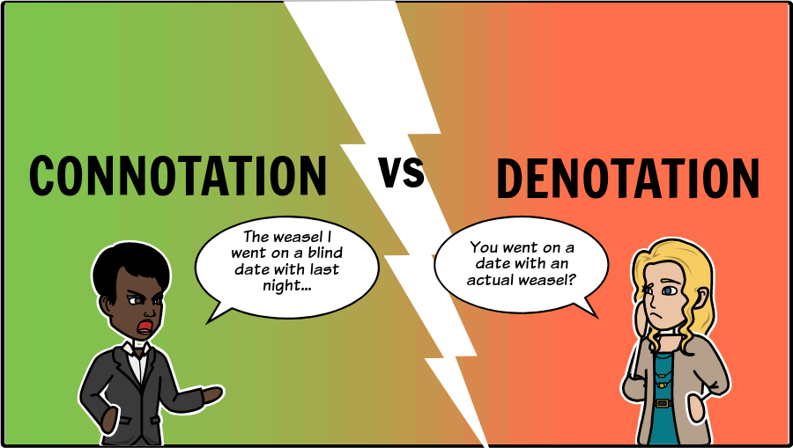

### **2. Connotation**

* **Definition:** Connotation refers to the **emotional, cultural, or implied meaning** that a word carries beyond its dictionary definition. It can be positive, negative, or neutral depending on context.
* **Example:**
  + *Snake* (connotation): danger, betrayal, evil.
  + *Rose* (connotation): love, romance, beauty.

### 

| **Word** | **Denotation (Dictionary Meaning)** | **Connotation (Implied/Emotional Meaning)** |
| --- | --- | --- |
| Home | A place where one lives | Warmth, family, comfort, security |
| Childish | Like a child | Immature, silly (negative) |
| Youthful | Young, not old | Energetic, lively (positive) |
| Cheap | Low in cost | Poor quality, inferior (negative) |
| Frugal | Careful with money | Wise spending, economical (positive) |

**Give the denotative and connotative meanings of the following pair of words and use them in your own sentences:  
Ans.**

### **1. Thrifty vs. Cheap**

* **Denotation:** Both mean “spending money carefully.”
* **Connotation:**
  + *Thrifty* → Positive (wise with money).
  + *Cheap* → Negative (unwilling to spend, low quality).
* **Sentences:**
  + My grandmother is **thrifty**; she saves money without compromising quality.
  + He bought a **cheap** phone that broke after a week.

### **2. Determined vs. Stubborn**

* **Denotation:** Both mean “not giving up easily.”
* **Connotation:**
  + *Determined* → Positive (strong will, goal-oriented).
  + *Stubborn* → Negative (unreasonable, unwilling to listen).
* **Sentences:**
  + She was **determined** to finish her studies despite challenges.
  + The child was **stubborn** and refused to eat his vegetables.

### **3. Wise vs. Cunning**

* **Denotation:** Both relate to “intelligence or cleverness.”
* **Connotation:**
  + *Wise* → Positive (knowledgeable, fair, good judgment).
  + *Cunning* → Negative (sly, deceptive).
* **Sentences:**
  + The old teacher gave us **wise** advice for life.
  + The fox is often described as **cunning** in fables.

### **4. Frugal vs. Stingy**

* **Denotation:** Both mean “not spending much money.”
* **Connotation:**
  + *Frugal* → Positive (careful, economical).
  + *Stingy* → Negative (selfish, ungenerous).
* **Sentences:**
  + Being **frugal**, she managed to save enough for a new house.
  + He is too **stingy** to donate even a small amount to charity.

### **5. Confident vs. Arrogant**

* **Denotation:** Both mean “having self-assurance.”

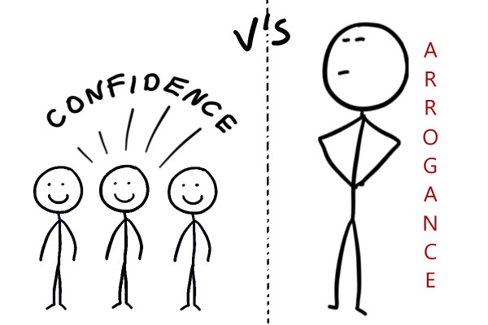

* **Connotation:**
  + *Confident* → Positive (self-belief, respectful).
  + *Arrogant* → Negative (overly proud, looking down on others).
* **Sentences:**
  + She was **confident** during her job interview and impressed the panel.
  + His **arrogant** remarks made everyone uncomfortable.

**Adverbs**

An **adverb** is a word that modifies a **verb**, an **adjective**, or another **adverb**. It tells us more about how, when, where, or to what extent an action is performed.

* **Example:**
  + She sings **beautifully**. (modifies the verb *sings*)
  + It is a **very** tall building. (modifies the adjective *tall*)
  + He ran **quite quickly**. (modifies the adverb *quickly*)

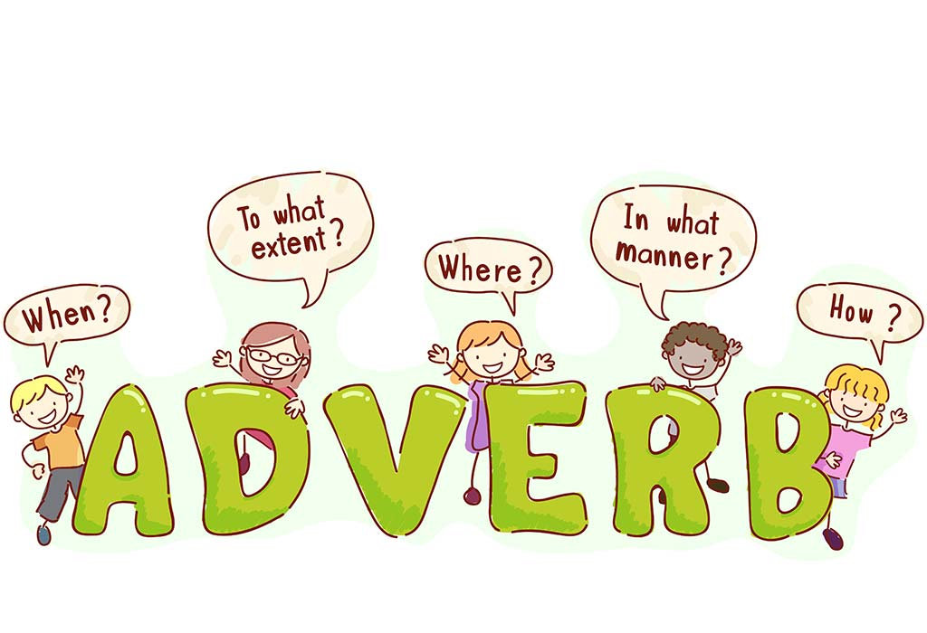

### **Types of Adverbs**

1. **Adverbs of Manner**
   * Show *how* an action is done.
   * Examples: quickly, slowly, carefully, beautifully.
   * Sentence: She spoke **politely** to her teacher.
2. **Adverbs of Time**
   * Tell *when* an action happens.
   * Examples: today, yesterday, soon, later, always.
   * Sentence: I will call you **tomorrow**.
3. **Adverbs of Place**
   * Show *where* an action happens.
   * Examples: here, there, everywhere, outside, upstairs.
   * Sentence: The children are playing **outside**.
4. **Adverbs of Frequency**
   * Tell *how often* something happens.
   * Examples: always, often, rarely, never, sometimes.
   * Sentence: He **always** wakes up early.  
     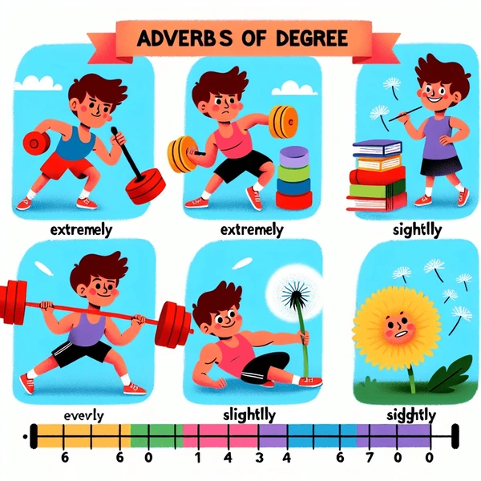
5. **Adverbs of Degree (or Quantity)**
   * Show *how much* or *to what extent*.
   * Examples: very, too, almost, quite, enough, extremely.
   * Sentence: She was **too** tired to continue.
6. **Interrogative Adverbs**
   * Used to ask questions.
   * Examples: when, where, why, how.
   * Sentence: **Where** are you going?
7. **Relative Adverbs**
   * Introduce clauses and connect them to nouns or pronouns.
   * Examples: when, where, why.
   * Sentence: I remember the day **when** we first met.

**Q: Read the following sentences and identify the adverbs. Also mention the type of adverb.  
Ans.**

**i.** Javeria **confidently** answered all the questions during the interview. She speaks English **fluently** and practices **attentively** every day at the language institute.

* **confidently** → Adverb of Manner (how she answered)
* **fluently** → Adverb of Manner (how she speaks)
* **attentively** → Adverb of Manner (how she practices)
* **every day** → Adverb of Time (when she practices)

**ii.** Laila **quickly** completed her homework before heading to the library. She studies **diligently** and **always** finishes her assignments on time to relax.

* **quickly** → Adverb of Manner (how she completed)
* **diligently** → Adverb of Manner (how she studies)
* **always** → Adverb of Frequency (how often she finishes)
* **on time** → Adverb of Time (when she finishes)

**iii.** Murtasim **patiently** waited for his friends at the cafe. He **usually** meets them on Fridays after work for a relaxing evening.

* **patiently** → Adverb of Manner (how he waited)
* **usually** → Adverb of Frequency (how often he meets)
* **on Fridays** → Adverb of Time (when he meets)
* **after work** → Adverb of Time (when he meets)

**Adverbial Phrase**

An **adverbial phrase** is a group of words (without a verb) that functions as an **adverb** in a sentence. It modifies a verb, adjective, or another adverb by telling **how, when, where, why, or to what extent** an action happens.

### **Types of Adverbial Phrases**

1. **Adverbial Phrase of Manner**
   * Describes *how* an action is performed.
   * **Examples:**
     + He spoke **in a loud voice**.
     + She ran **with great speed**.
2. **Adverbial Phrase of Place**
   * Describes *where* an action takes place.
   * **Examples:**
     + They live **in the city center**.
     + The children are playing **in the garden**.

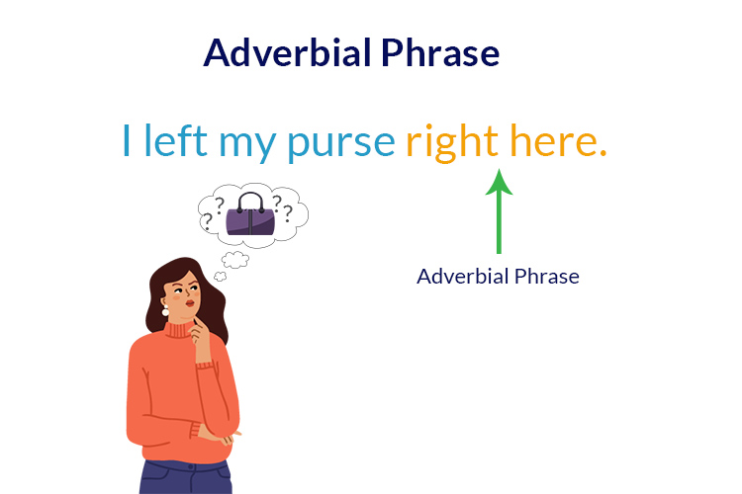

1. **Adverbial Phrase of Time**
   * Describes *when* an action happens.
   * **Examples:**
     + We will meet **at noon**.
     + He arrived **after the party**.
2. **Adverbial Phrase of Reason (or Cause)**
   * Explains *why* an action happens.
   * **Examples:**
     + She was absent **because of her illness**.
     + He succeeded **due to his hard work**.
3. **Adverbial Phrase of Frequency**
   * Tells *how often* something happens.
   * **Examples:**
     + She visits her grandmother **once a week**.
     + They go for a walk **every morning**.
4. **Adverbial Phrase of Purpose**
   * Explains *for what reason/purpose* something is done.
   * **Examples:**
     + He worked hard **to pass the exam**.
     + She left early **to catch the bus**.
5. **Adverbial Phrase of Degree**
   * Shows *how much* or *to what extent*.
   * **Examples:**
     + The athlete trained **to a very high level**.
     + She was tired **to an extreme degree**.

### **Difference between Adverb and Adverbial Phrase**

* **Adverb:** single word → *She spoke* ***loudly***.
* **Adverbial Phrase:** group of words → *She spoke* ***in a loud voice***.

**Read the following sentences and identify the adverbial phrases. Consider the questions they answer (how, when, where, etc.) and the role they play in modifying the verbs, adjectives, or adverbs.  
Ans.**

**i.** She completed the puzzle **with great concentration**.

* *Question:* How?
* **Adverbial Phrase of Manner**

**ii.** We will meet **at the park after sunset**.

* *Question:* Where? / When?
* **Adverbial Phrase of Place & Time**

**iii.** The students gathered **in the library to study for their exams**.

* *Question:* Where? / Why?
* **Adverbial Phrase of Place & Purpose**

**iv.** He exercises **at the gym three times a week**.

* *Question:* Where? / How often?
* **Adverbial Phrase of Place & Frequency**

**v.** The temperature dropped quite suddenly **in the evening**.

* *Question:* When?
* **Adverbial Phrase of Time**

**vi.** They danced **with incredible grace at the party**.

* *Question:* How? / Where?
* **Adverbial Phrase of Manner & Place**

**vii.** The train departed **at midnight**.

* *Question:* When?
* **Adverbial Phrase of Time**

**viii.** She visits her grandparents **every summer**.

* *Question:* When? / How often?
* **Adverbial Phrase of Time & Frequency**

**ix.** He spoke **with a surprisingly loud voice during the presentation**.

* *Question:* How? / When?
* **Adverbial Phrase of Manner & Time**

**x.** The mountain climbers reached the summit **with considerable difficulty**.

* *Question:* How?
* **Adverbial Phrase of Manner**

**Verbals**

A **verbal** is a word formed from a verb, but it functions as a **different part of speech** (noun, adjective, or adverb) instead of acting as the main verb in a sentence.

### **Difference between Verb and Verbal**

* **Verb:** expresses action or state of being. → *She runs every morning.*
* **Verbal:** looks like a verb but functions differently. → *She likes* ***running****.*

**

**Gerunds**

A **gerund** is the **-ing form of a verb** that functions as a **noun** in a sentence. Even though it looks like a verb, it does not show action; instead, it names an activity or idea.

* **Example:** *Reading* is my favorite hobby.  
   (Here, *reading* is the subject of the sentence, so it acts as a noun.)

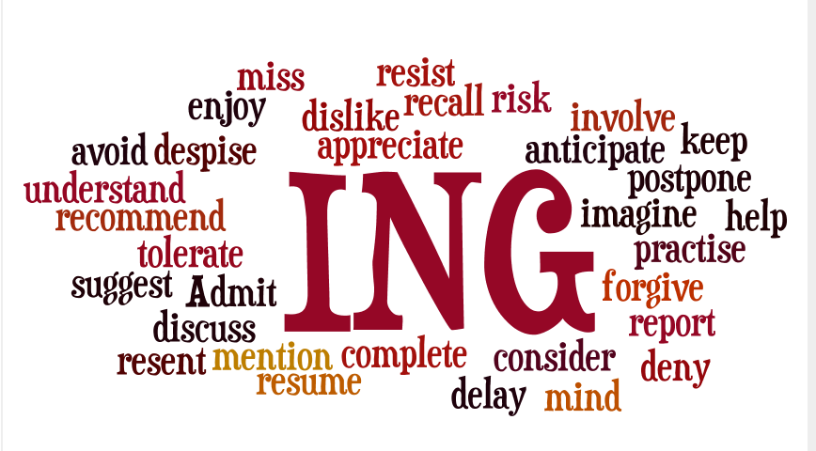

### **Examples in Sentences**

* **Running** every morning keeps me healthy. (subject)
* I enjoy **writing** stories. (object of verb)
* She is good at **drawing**. (object of preposition)
* His dream is **becoming** a doctor. (subject complement)

**Read the passage and identify the gerunds.   
Ans.**

The life on a farm is full of interesting activities. **Reading** by the barn, **swimming** in the pond, **hiking** through small hills, horse **riding** at sunset, **farming** from dawn till dusk, and cattle **rearing** with care are some of them. Each task woven into the rhythm of farm life, **making** every day an adventure under the wide sky.

**Infinitives**

An **infinitive** is the **base form of a verb**, usually preceded by **“to”** (to + verb). It can function as a **noun, adjective, or adverb** in a sentence.

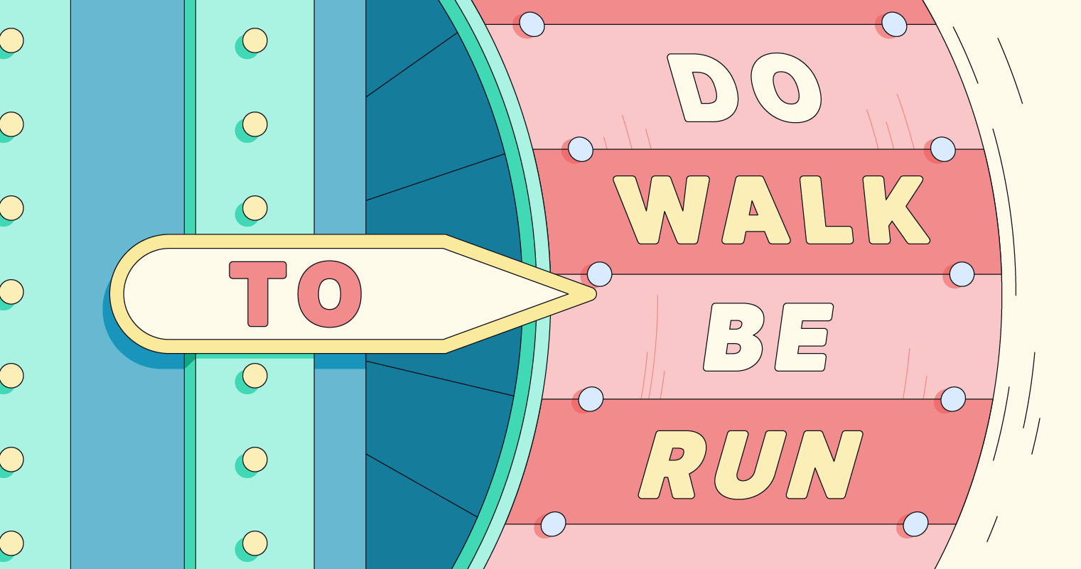

* **Examples:**
  + I like **to read**. (noun)
  + She has a book **to write**. (adjective)
  + He came **to help**. (adverb)

### **Why Do We Use Infinitives?:**

1. **To express purpose or intention**
   * She works hard **to achieve** her dreams.
2. **To explain reason or cause**
   * I am happy **to see** you again.
3. **To function as nouns in a sentence**
   * **To travel** is my greatest wish.
4. **To make writing concise and flexible**
   * Instead of long clauses, infinitives simplify expression.
   * *She made a decision* ***to leave.*** (instead of *She made a decision that she would leave.*)
5. **To follow certain verbs, adjectives, or nouns**
   * Verbs: want, need, decide, plan → *I want* ***to go.***
   * Adjectives: happy, eager, ready → *She is ready* ***to help.***

**Identify and underline the infinitive in each sentence.  
Ans.**

i. We decided ***to visit*** the museum next weekend.

ii. Aqsa's goal is ***to complete*** the marathon in a record time.

iii. I would like ***to learn*** a new language before I turn 30.

iv. The best time ***to plant*** a tree is now.

v. Our plan is ***to travel*** to Makkah next summer.

vi. I need ***to finish*** my homework before dinner.

vii. Hasan hopes ***to become*** a successful entrepreneur.

viii. It is essential ***to exercise*** regularly for good health.

ix. The purpose of the meeting is ***to discuss*** upcoming projects.

x. Atiqa promised ***to help*** the community center with fundraising.



